**T****IMEX® Corporation**

**Run x50+**

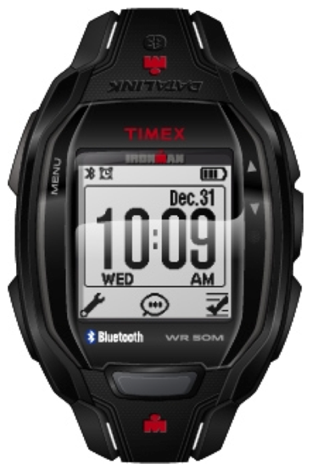

**Fitness Mode**

**Best Practices Guide**

**Rev 3**

July 11, 2014

Table of Contents

1. Introduction 3

2. The Watch Experience 3

3. Watch Hardware 3

Screen Size 3

Buttons 3

Notifications and Alerting 5

Light 5

Alerting the User 5

4. Timex Supported API Calls 5

Watch Sound / Vibration 5

Backlight 6

Pages 6

Display Text Inversion 7

Version 7

5. Fonts and Graphics 7

Fonts 7

Display Screens 7

Single Metric Display 8

Dual Metric Display 9

Three Metric Display 10

Icons 11

# Introduction

The Timex Run x50+ watch is not your standard Grandpa’s Timex – this device is a full-featured sport watch with a Bluetooth 4.0 connection to a smart phone. The watch receives notifications from an iOS or Android based smart phone, lets the user control music on the phone from the watch and links third party apps (you) to the watch.

This guide provides some best practice information for Mobile App developers who are integrating the Timex Run x50+ device into their application.

# The Watch Experience

The watch user interface is a completely new direction for Timex. The watch has six buttons that are context sensitive. Labels and icons are used on the watch face to indicate button functions within different apps. This makes it extremely easy to figure out how to navigate the watch.

There is a Fitness mode within the watch where the connection between the smartphone app using the Wahoo Fitness Dual Screen API takes place. The user brings up the menu and selects the “Fitness” mode. Once the user enters this mode, the watch and phone app setup their link (pairing) to each other.

Once paired, the phone app sends the screen configuration down to the watch. It is up to you as a developer to either choose the Timex default configuration or to create your own configuration.

Timex feels that our implementation is better than others in the market:

* The watch has other functions besides just the RFLKT mode (chrono, alarms, interval timer)
* You can move between watch apps and fitness mode without affecting the other.
* Full connectivity (notifications, e-mails, alarms, appointments, etc.)

# Watch Hardware

This section describes the hardware that is present on the Run X50+ watch.

## Screen Size

The watch uses a Sharp Memory 1.28” LCD (Model # LS013B7DH03) for its display. The watch LCD screen is 128 pixels high by 128 pixels wide with a 0.18 mm square dot pitch. Please take this into account when designing custom display screens.

More information may be found at Sharp’s web site: <http://www.sharpmemorylcd.com/1-28-inch-memory-lcd.html>

## Buttons

The watch consists of six buttons, three on the right side, two on the left side and one on top. Each button is labeled as shown:



The MENU button is reserved for the Application Menu. The CONTEXTUAL A button is reserved for music control. **Neither of these buttons are available for use by your app.**

The remaining four buttons (UP, DOWN, PRIMARY ACTION and CONTEXTUAL B) are available for your app’s use. Here are some suggested best practices for their usage:

* The UP and DOWN buttons should be used to increment or decrement items respectively. They can also be used to change pages, which is done in the default configuration.
* If the phone application is timing related, the PRIMARY ACTION button should be used to start a timing operation and take laps (if laps are available within your app). The watch’s chronograph mode uses this button to start and take laps so this keeps the watch experience consistent.
* Again, if the phone app is timing specific, the CONTEXTUAL B button should be used to stop the timing session and optionally reset the session after it has been stopped. The watch also uses this button to stop, followed by resetting, a built-in timing workout.

Also, it should be noted that the same function should not be replicated on multiple buttons. For example, if the UP and DOWN buttons are assigned for a page change, then it is suggested to not add a page change operation to other buttons.

The configurable buttons may be assigned the following SDK button functions: PAGE_LEFT, PAGE_RIGHT, YES or NO. However, the YES and NO SDK functions are ignored on the watch side. PAGE_LEFT and PAGE_RIGHT assigned buttons will cause the watch to scroll to the next or previous page, accompanied by a button beep. There is no need to send a SET_PAGE command.

Note that buttons do not have to be configured. The watch will pass button presses by location with the following values:

* UP = 1
* DOWN = 2
* CONTEXTUAL B = 3
* PRIMARY ACTION = 4

Along with the button press, the press duration of the button (milliseconds) is sent back to the SDK which can then be captured and processed within your app.

## Notifications and Alerting

The watch includes an LED light with ambient light detection circuit, a vibrating motor and a piezo beeper for notifying and alerting the user of various events.

### Light

On the watch, the user has various options of how the light activates. By default, the light is enabled for 3-4 seconds when the user taps the screen, and the ambient light sensor determines that the watch is in a dark place. Other options include constant on, where the light stays on permanently until the user changes the setting regardless of the ambient light sensor status, and Night-Mode, where the light comes on when any button is pressed, provided the ambient light sensor determines that the watch is in a dark place.

The light can be turned on from your app programmatically via API calls. The watch treats this request as a tap event, meaning it is processed the same way as a user-initiated lamp request, with the same ambient light sensor rules. If the watch is in constant on mode, the watch ignores the ON request as the lamp is already on..

Requests to turn the lamp off via XXXX API are ignored, as the watch manages this function itself.

A good example of using the light - when a lap is taken, the user may hear the indication and want to look at the display. Turning the lamp on will give the user the ability to see the display if it is dark outside, without having to tap on the watch.

### Alerting the User

The watch’s vibrating motor can be enabled via API calls. The duration of the vibration is < 1 s. The watch also has a button beep sound, which when called from the API, generates a short beep < 100 ms.

The API can send a single button beep only, a single vibrate pattern, or a combination of the two. Please see the section below for more details.

Good examples of alerting the user are the following:

* The user starts or stops a timing session, or takes a lap within the session
* The user is currently outside of a training zone

It should be noted, if the user is listening to music from the phone with their headphones, the vibration alert is more effective at alerting the user.

# Timex Supported API Calls

This section describes the Wahoo Fitness API calls used within the watch. APIs are responded to all the time, regardless of what mode the user is in on the watch. All API calls listed below rely on the Wahoo Display Control Point Characteristics.

## Watch Sound / Vibration

**WF_DISPLAY_CP_OPCODE_PLAY_SOUND, BINARY_KEY, SOURCE, REPEAT**

WF_DISPLAY_CP_OPCODE_PLAY_SOUND = 0x12,

BINARY_KEY

* 0x01 = Beep only
* 0x02 = Vibrate only
* 0x03 = Beep and Vibrate

SOURCE = 1 (always)

REPEAT = 0 (repeat is not available)

## Backlight

**WF_DISPLAY_CP_OPCODE_SET_BACKLIGHT, STATE**

WF_DISPLAY_CP_OPCODE_SET_BACKLIGHT = 0x02,

STATE = TRUE (FALSE is ignored)

**WF_DISPLAY_CP_OPCODE_GET_BACKLIGHT**

WF_DISPLAY_CP_OPCODE_GET_BACKLIGHT = 0x05,

Always returns FALSE.

## Pages

**WF_DISPLAY_CP_OPCODE_SET_PAGE, PAGE, TIMEOUT**

WF_DISPLAY_CP_OPCODE_SET_PAGE = 0x03,

PAGE = page key (0- 254)

TIMEOUT = seconds

NOTE: You must assign page key ‘0’ to your first or default or only page. Subsequent page keys can be anything between 1 and 254. If timeout is set to anything other than 0, then the watch will return to the previous page after the set timeout expires.

**WF_DISPLAY_CP_OPCODE_GET_PAGE**

WF_DISPLAY_CP_ OPCODE_GET_PAGE = 0x06,

RETURNS: Currently displayed page index.

**WF_DISPLAY_CP_OPCODE_SET_AUTO_PAGE_SCROLL , TIMEOUT**

WF_DISPLAY_CP_OPCODE_SET_AUTO_PAGE_SCROLL = 0x0D,

TIMEOUT = milli-seconds

Note: Range of scroll timeout is from 500ms to 65000ms. To stop auto scroll, set TIMEOUT to 0 in a subsequent call to WF_DISPLAY_CP_OPCODE_SET_AUTO_PAGE_SCROLL

## Display Text Inversion

**WF_DISPLAY_CP_OPCODE_SET_INVERTED, STATE**

WF_DISPLAY_CP_OPCODE_SET_INVERTED = 0x0A,

STATE = TRUE, Inverted display (white text)

STATE = FALSE, Normal display (black text)

**WF_DISPLAY_CP_OPCODE_GET_INVERTED**

WF_DISPLAY_CP_OPCODE_GET_INVERTED = 0x0B,

TRUE = Inverted display is ON

FALSE = Inverted display is OFF

Note: It is suggested to use WF_DISPLAY_CP_OPCODE_GET_INVERTED call prior to WF_DISPLAY_CP_OPCODE_SET_INVERTED to achieve the desired effect.

## Version

**WF_DISPLAY_CP_ OPCODE _GET_CONFIG_VERSIONS**

WF_DISPLAY_CP_OPCODE_GET_CONFIG_VERSIONS = 0x0C,

Returns number of versions supported = 1 and current version = 1 (currently, only configuration files of version 1 are supported)

# Fonts and Graphics

## Fonts

There are five sets of fonts available. A table of the fonts and their supported character sets are listed below:

|  |  |  |  |
| --- | --- | --- | --- |
| **Font Name** | **Font Height** | **Font Max Width** | **Characters Supported** |
| 10 Pixel | 10 | 19 (% char) | Space “ % ‘ + , - . / 0-9 : A-Z |
| 12 Pixel | 12 | 19 (% char) | Space “ % ‘ + , - . / 0-9 : A-Z |
| 14 Pixel | 14 | 20 (% char) | Space “ % ‘ + , - . / 0-9 : A-Z |
| 26 Pixel | 26 | 36 (W char) | Space “ % ‘ + , - . / 0-9 : A-Z ° |
| 39 Pixel | 39 | 53 (W char) | “ % ‘ + , - . / 0-9 : A-Z ° |

## Display Screens

For Fitness screen layout, the Timex default configuration supports the following display (single metric, dual metric and three metric):

Timex recommends that if you customize the display, you should follow these guidelines:

* Display the music icon on the bottom left. This button is always used for music control so it would be a good idea to show the user that this function is available
* If using the Primary Action button (the one on the top of the watch case), it is recommended that you show text indicating what this button does within your display. Note the font usage and the maximum width as shown in the display examples below.
* If using the Contextual B button, show a graphic icon of what this button does
* The 12 x 12 pixel icon in the top left should be a graphic indicating your application
* If your app supports multiple pages, it is suggested that you follow the page indicator as shown on the top right of the displays. Each small dash indicates a page while the larger rectangle indicates the current view page from your app.

### Single Metric Display



### Dual Metric Display

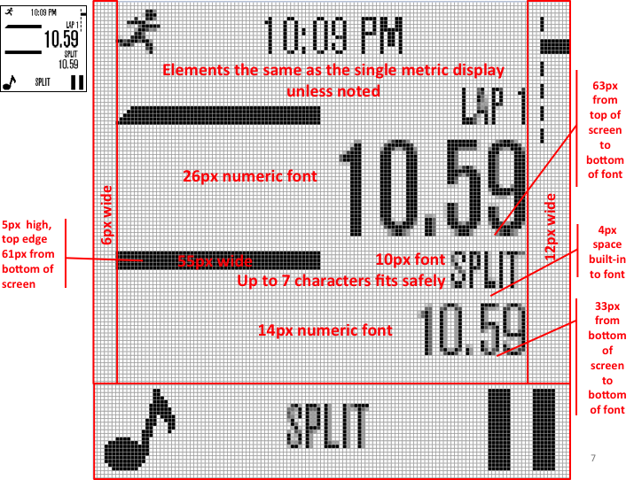

### Three Metric Display

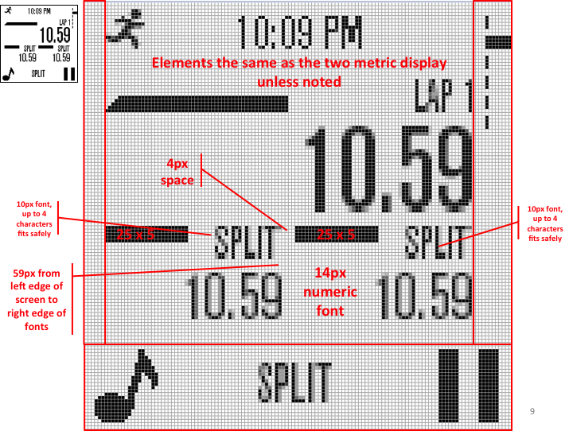

## Icons

Icons need to be defined within the default configuration files. We have included a zip file containing all of the icons listed below. These may be included in your Wahoo Fitness display to keep the watch user experience the same across all of the watch UI. All icons are 26 x 26 pixels.

The icons should be run through the Wahoo bitmap converter utility to create assets for your configuration file.

|  |  |
| --- | --- |
| **Icon** | **Description** |
| Macintosh HD:Users:bthorp:Desktop:M054 Icons v6 05-07-2014:alarm-repeat26x26.png | Alarm repeat |
| Macintosh HD:Users:bthorp:Desktop:M054 Icons v6 05-07-2014:appointment-list26x26.png | Appointment |
| Macintosh HD:Users:bthorp:Desktop:M054 Icons v6 05-07-2014:cancel26x26.png | Cancel |
| Macintosh HD:Users:bthorp:Desktop:M054 Icons v6 05-07-2014:configure26x26.png | Configure (Settings) |
| Macintosh HD:Users:bthorp:Desktop:M054 Icons v6 05-07-2014:confirm26x26.png | Confirm or save workout |
| Macintosh HD:Users:bthorp:Desktop:M054 Icons v6 05-07-2014:delete-workout26x26.png | Delete workout |
| Macintosh HD:Users:bthorp:Desktop:M054 Icons v6 05-07-2014:finishworkout26x26.png | Finish workout |
| Macintosh HD:Users:bthorp:Desktop:M054 Icons v6 05-07-2014:music-player26x26.png | Music player |
| Macintosh HD:Users:bthorp:Desktop:M054 Icons v6 05-07-2014:next-track26x26.png | Next track |
| Macintosh HD:Users:bthorp:Desktop:M054 Icons v6 05-07-2014:next26x26.png | Next item or screen |
| Macintosh HD:Users:bthorp:Desktop:M054 Icons v6 05-07-2014:notifications26x26.png | Notifications |
| Macintosh HD:Users:bthorp:Desktop:M054 Icons v6 05-07-2014:pause-workout26x26.png | Pause workout |
| Macintosh HD:Users:bthorp:Desktop:M054 Icons v6 05-07-2014:previous-track26x26.png | Previous track |
| Macintosh HD:Users:bthorp:Desktop:M054 Icons v6 05-07-2014:previous26x26.png | Previous item or screen |